Organic Food Industry Trend Report

Ruriko Imai

November 8, 2017



# TABLE OF CONTENTS

**Executive Summary …...Page 3**

**Introduction …...Page 4-7**

**Why Organic is a rising trend …...Page 4-5**

**Figure 1**

**Figure 2**

**What does being “Organic” actually mean? …...Page 6-7**

**Figure 3**

**Figure 4**

**Stakeholders …...Page 7-10**

**Consumer Interest ..….Page 7-9**

**Figure 5**

**Producer Interest …...Page 9-10**

**Figure 6**

**Funding …...Page 10**

**Organic Trend Today …...Page 10-12**

**Clean Trends**

**Hospital Trends**

**Plant-based Eats**

**Baby Food Trends**

**Future Organic Trend …...Page 12-14**

**Japan’s No. 1 Organic Miso maker**

**Gene Alteration**

**Organic Wine**

**Online Shopping Trend**

**References …...Page 15-16**

**Executive Summary**

The sales of the organic food market is on the rise since the 1990s when it started developing. Retail sales of organic food increased from $3.6 billion in 1997 to $21.1 billion in 2008. During 2000 to 2015, the Organic Trade Association declared the retail sales to be $43.3 billion, showing a double-digit growth in the industry.

Consumers, especially the millennials, care about this industry since they are becoming more health conscious. Consumer demands are the driving force in this industry as new products emerge on a daily basis to excite and satisfy their needs and wants. With the help of accessible data by numerous funding of the organic farming operations, the population has greater access to the data now more than ever before. The number of producers is also growing as funding help farmers make a smooth transition to organic farming.

More knowledge and exposure to the differences between organic products and non-organic increases the likelihood of consumers choosing to purchase organic. There are persistent arguments over the terms healthy, natural and organic that will keep resurfacing as long as skepticisms towards the validity of the terms persist. However, the future is bright as advances in scientific research and the sustainability of its production methods help clean and produce better products over time. In the meantime, skeptical consumers will keep criticizing and their opinions will also contribute to the growth of the organic industry as it has helped in the very first phase of defining the term “organic”.

This industry will keep rising as more innovative ideas and scientific methods are introduced. The market will expand with the involvement of online shopping such as through Amazon and THRIVE market for example and also will keep expanding at the global level. Trends such as plant-protein and plant-dairy will rise constantly as health enthusiasts find a new hobby to latch on to such as the Paleo and raw food diet. Organizations concerned with animal welfare will also take part in the organic food industry to insure animal safety and upkeep of moral standards for meat products. In the near future, as organic spreads and become known to a larger population, hopefully the food that we consume will be all organic since we always say, “We are what we eat”.

**Introduction**

Consumption of food is a necessity that cannot be removed from our daily lives. We purchase food at the grocery stores, farmer markets, restaurants, etc. Although we consume it everyday there is a great chance of us not knowing its source. The issue roots from the lack of transparency in the food chain system that makes it difficult for us to trace back to its source. The apple you were eating today might be a product from your neighborhood, Mexico or Thailand, and contain 200 different types of pesticides that are causing heart issues -- The point is, we don’t know where the foods are from and how they are being processed. So how can we possibly address this issue? The answer might just lie in the organic farming industry, an industry that aims to grow its products in a transparent and sustainable manner. The organic food industry is a rising trend that is revolutionizing the food industry as new trends emerge daily to meet consumer’s interests and producer’s interests which are becoming more health focused and environmentally friendly.

**Why Organic is rising**

The driving factor behind the growth of the organic industry stems from the concerns of possible health issues because of the pesticides and various chemicals which are used to grow conventional crops. To meet this concern the millennial population in large is contributing to the growth of organic products due to greater exposure and knowledge of organic products and their benefits. Farmers convert to organic farming to protect family members and farm workers from chemicals as well as to promote environmental and economical sustainability. With the help from the community, the organic industry is growing at an exponential rate as retail sales of organic food increases from $3.6 billion in 1997 to $21.1 billion in 2008 (Dimitri and Oberholtzer, 3). The updated retail sales are shown in the graph below (Figure 1). During 2000 to 2015, the Organic Trade Association estimated the retail sales to be $43.3 billion, showing a double-digit growth in the industry. Now, there are over 21,700 certified organic operations across the U.S. (Greene et al, 36).

(Figure 1)

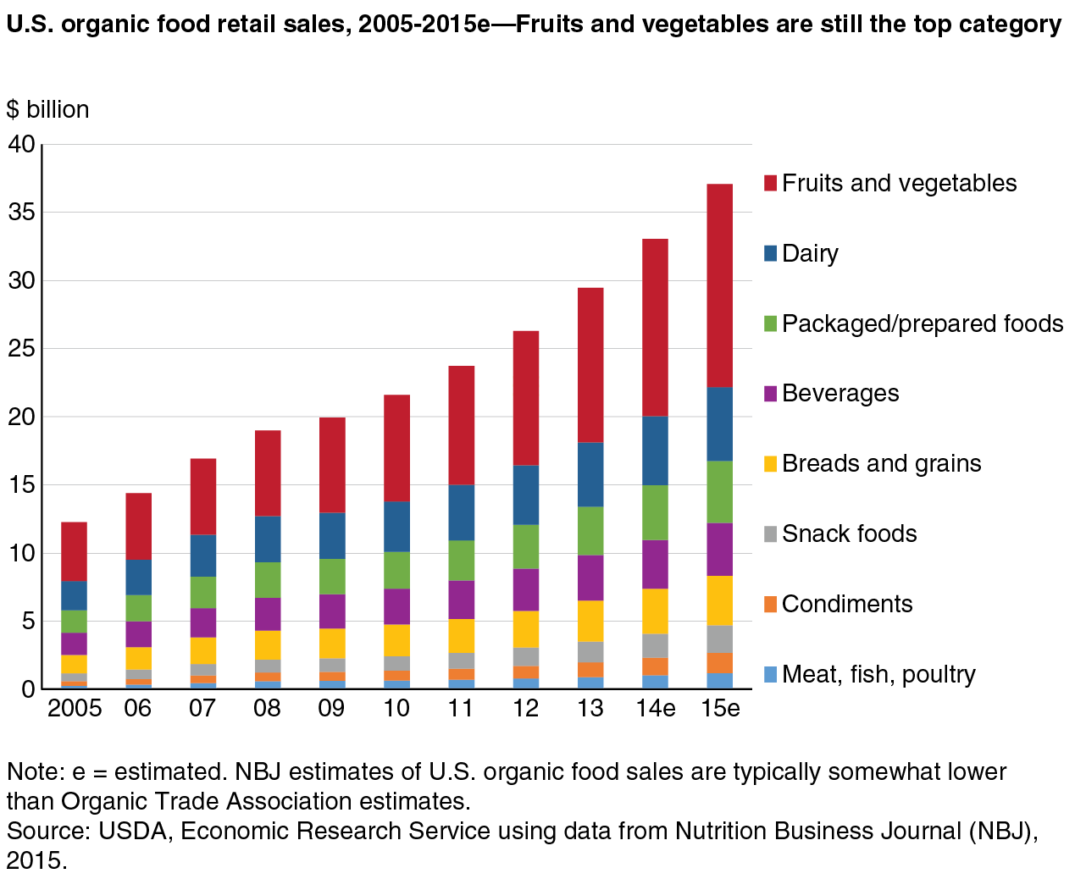

The sudden rise of consumer demands for organic food inevitably led to imbalance of supply and demand. Due to periodic shortages, organic farms struggled to provide sufficient products to the market, hindering the market’s growth (Figure 2). Although organic farmland acreage more than doubled from 1997 to 2005, the expansion of organic farmland scrambled to keep up with the consumer’s demand. Many farmers also failed to convert to organic farming due to complications of processes that they needed to undergo (Dimitri and Oberholtzer, 4). However, the progress for conversion is less of a financial burden now as farmers are encouraged and supported by the stakeholders of the organic sector which will be introduced later.

(Figure 2)

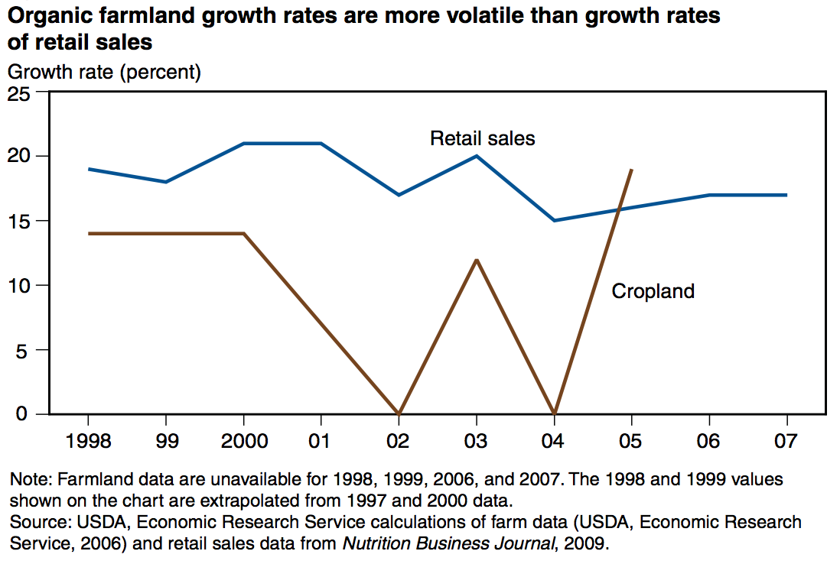

**What does being “Organic” actually mean?**

Aside from the producer’s issues that arose with the growth of the organic industry, there are many concerns shown by the consumers as well. The main debate that persists in this industry is the precise definition of the term, “organic”. The issues arise from the failure of the Food and Drug Administration (FDA) to clarify the word, “Natural”, which is commonly used as a synonym of organic (Berry, 50).

The term “organic farming” started in the 1990s and has developed significantly as the United State Department of Agriculture (USDA) stepped in to standardize its definition. Now, farmers are required to dedicate to organic farming for 3 years before being permitted to label its products as organic.

Although the definition of organic farming improved, consumers still question the quality of products meeting its standards. In a survey, a quarter of the U.S. population composed mostly of seniors indicate never having bought organic products. The two main reasons when asked are the cost and skepticism. Cost of organics is much higher than non-organics and as the skeptics point out, there is no proof yet that organic products are healthier (Gardyn, 34). Good quality and unique attributes come with a higher market price. However, it also motivates farmers to improve on their products and to further refine and meet the quality that consumers expect.

(Figure 3)

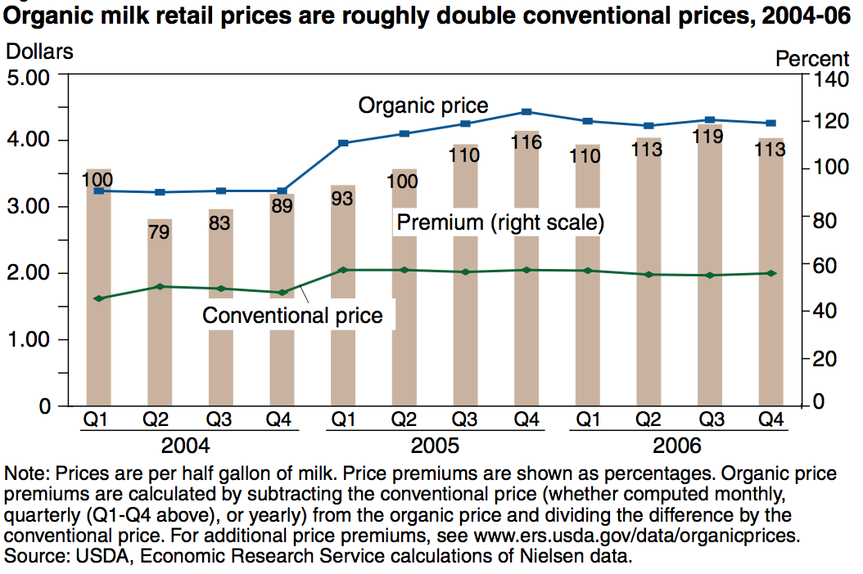

In order to prevent producers and handlers from putting misleading labels or fake labels on nonorganic products, USDA set a regulation on how to produce organic foods. Some examples are to avoid synthetic pesticides and fertilizers, genetic engineering, and sewage sludge. Others include the build of soil quality and use of crop rotation to help manage pests and disease amongst other benefits. The organic livestock systems include regulations such as ban of antibiotics and growth hormones. Accommodation of natural nutritional and behavioral needs, provision of organic feed, and vaccination of livestock are also required. The organic labeling requirements are separated into four categories:

1. “100-percent organic” label—only organic ingredients, excluding water and salt.
2. “Organic” label*—*at least 95 percent organic ingredients.
3. “Made with organic ingredients” label*—*at least 70 percent organic ingredients.
4. Listing in ingredients panel only—if less than 70 percent organic ingredients.

(Figure 3)

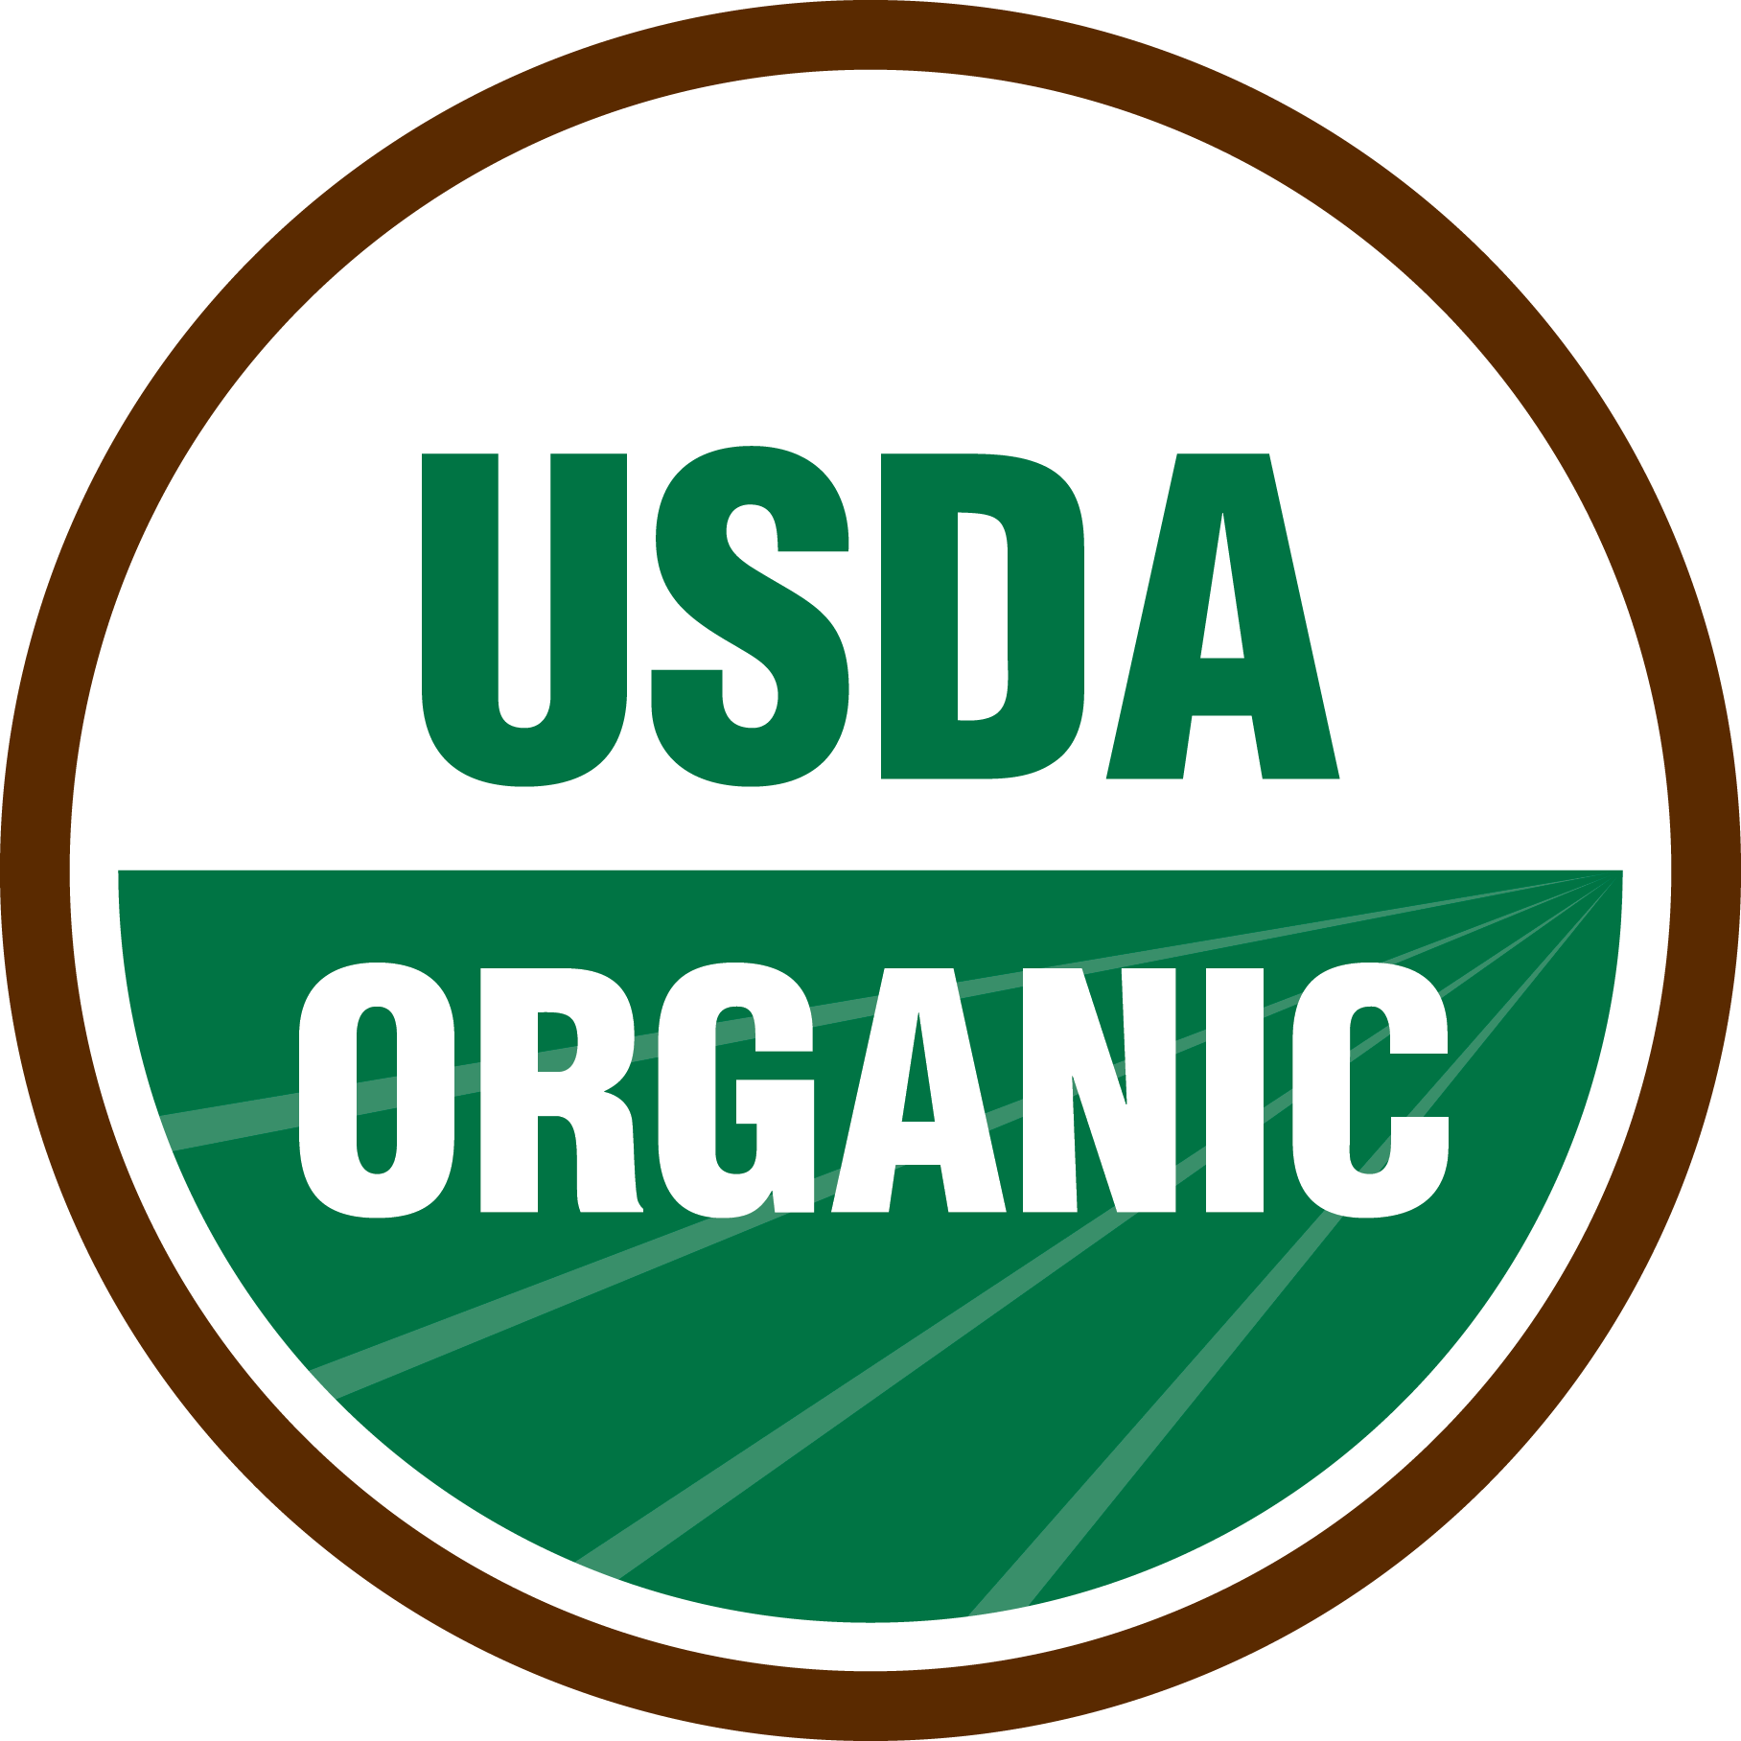

TheUSDA seal can only be used for “100-percent organic” and “Organic” products (Greene et al, 39-40).

As consumers are keeping a keen eye for cleaner products, the organic market competition is becoming more flexible and creative with labeling products and taking close care as to produce better quality organic products that consumers are looking for.

**Stakeholders**

**Consumer Interest**

The expansion in the organic industry shows nearly 20,000 natural food stores and approximately 3 out of 4 conventional grocery stores stocking up on organic products. Additionally, according to recent industry statistics, organic sales account for over 4 percent of U.S. total food sales. The three main venues in the U.S. at which organic items are accessible are: conventional grocery stores, natural food stores, and direct-to-consumer markets (Dimitri and Greene, 16). Although this indicates that consumers everywhere have access to organic items, consumer behavior across the regions, and education levels highly correlate with the level of which organic products are consumed.

(Figure 4)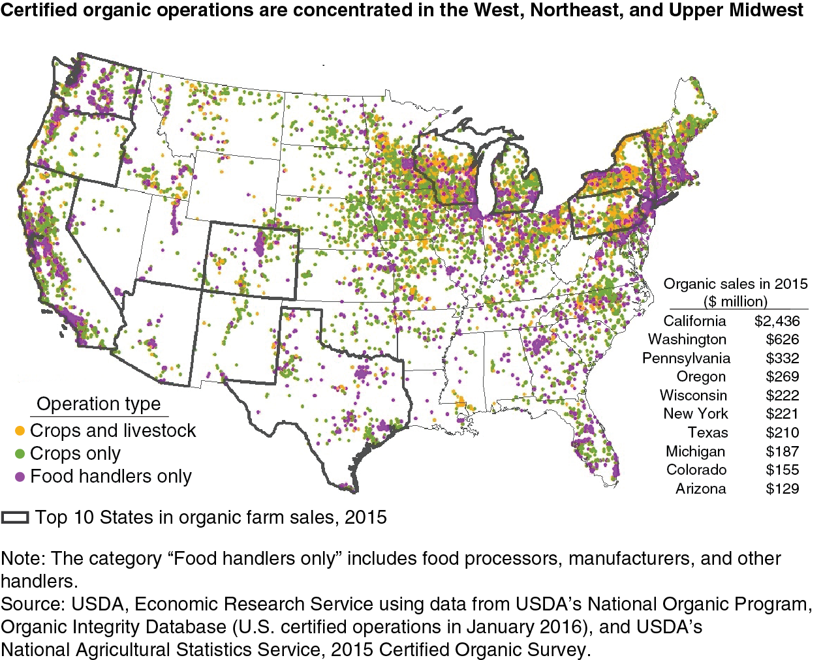

According to a source, the top 10 states for organic farm sales were California, Washington, Pennsylvania, Oregon, Wisconsin, New York, Texas, Michigan, Colorado, and Arizona. These States accounted for 78 percent of the total value of all U.S. certified organic commodities sold in 2015. California alone contributed 39 percent of total U.S. organic farm sales (Greene et al). The population that consumes organic products within those regions are mostly millennials of which 75-80 percent have purchased organic products at some point according to a national telephone survey conducted by The Walnut Acres/RoperASW on a representative sample of 1,032 adults. Of the millennials, 22 percent always purchase organic food when they shop at grocery stores compared to 17 percent of older populations. However, approximately a quarter of adults never bought organic foods before which are mostly seniors. Forty-two percent of seniors age 65 or older never bought organic foods, and 19 percent voiced that they rarely bought organic products. The two main reasons were: 38 percent of seniors indicated cost is high compared to other similar products, and 35 percent were skeptical of labeling (Gardyn, 34). As mentioned previously, the problem with labeling is resolved after the standardized USDA regulation of organic product labels, however, the drawback of high cost compared to other similar products may only be weighed by the individual’s importance towards their health and concerns of consuming GMO or pesticide affiliated foods.

**Producer Interest**

(Figure 5)

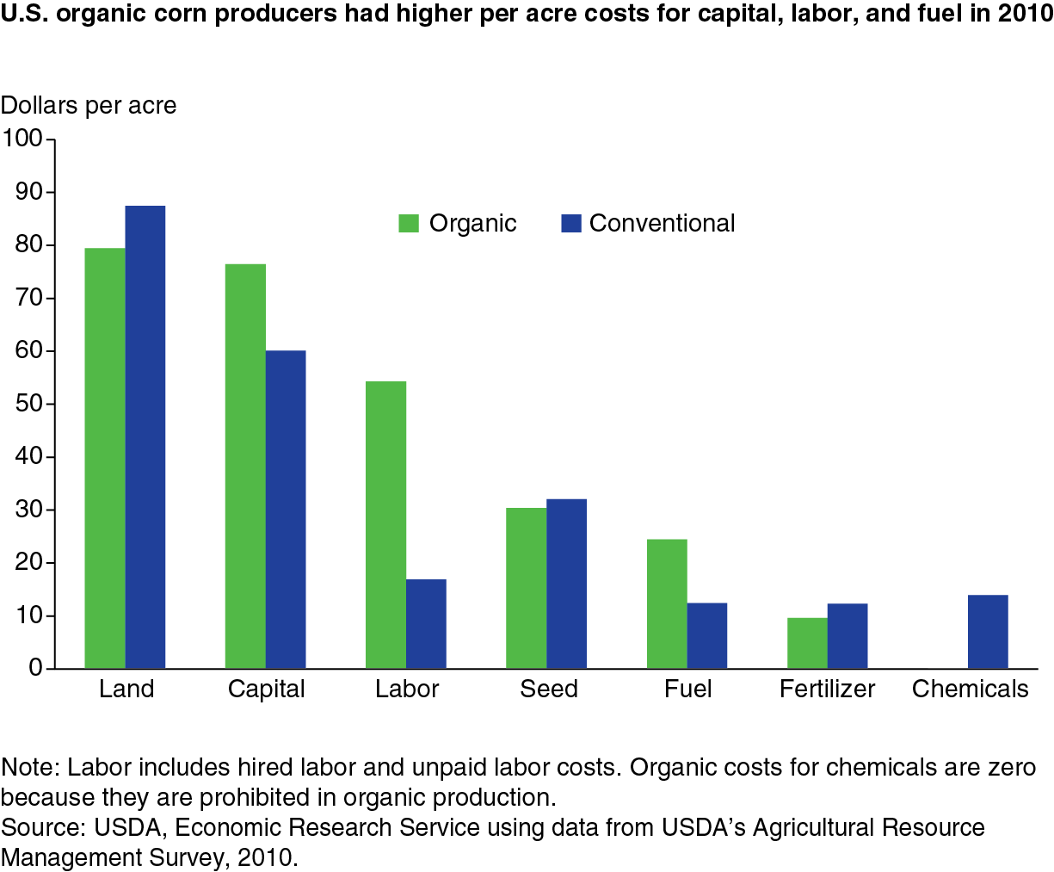

A similar attribute observed in consumer behavior appears amongst the producers as well; The majority of farm operators are composed of younger generations for the organic sector compared to other agricultural sectors. This phenomenon might be due to the fact that younger generations are exposed more to organic products and have grasped the importance and value, mainly health benefits, in organic products. Aside from the farmers, the organic sector is growing on the global scale as well. The U.S. is now the largest foreign organic supplier to Canada as well as a primary supplier for Mexico. We are the world’s top producers and exporters concerning organic corns and soybeans. Although the U.S. is at the top of the ladder in the organic industries globally, the import of organic products from foreign countries increased in 2015 due to the wide gap between production and demand. From this perspective, the suppliers in the U.S. have much more space to grow and should strive to reduce imports from foreign sources.

**Funding**

There are numerous funding programs and aids to promote organic farming. A brief excerpt of a long list of possible funding offered are: Cost-share assistance for organic certification, Environmental Quality Incentives Program (EQIP) Organic Initiative, Federal crop insurance, Organic Agriculture Research & Extension Initiative, Bilateral agreements to facilitate organic trade, etc. (Greene et al, 39).

The underlying concepts of these programs are to provide opportunities and incentives for farmers to start organic farming. For example, the Bilateral agreements to facilitate organic trade created an opportunity for the vending of certified organic goods in both countries that the USDA was able to negotiate with. Under the Federal crop insurance, the Congress recognized organic farming practices as good farming practices and expanded crop insurance coverage to organic producers (Greene et al, 39).

Aside from government’s support for organic farming systems, private sectors also provide initiatives and encouragement for the growth of the organic sector. Costco and Whole Foods for example pioneered pilot programs to offer financial assistance for organic farming. General Mills has developed partnerships with the Organic Valley dairy cooperative, organic advocacy groups, university researchers, and others to encourage the success of organic farming. These examples show the support from stakeholders in the food industry actively reaching out to help grow the organic industry, which has shown significant growth since the birth of the organic sector in 1997 (Greene et al, 39).

**Organic Trends Today**

The prominent rational for consumers purchasing organic products is the possible health benefits compared to buying inorganic products that may lead to health issues down the road. Therefore, trends that are observed in the industry today are emphasized on clean, simple foods that bring benefits to one’s health. There are also trends in industries that care for others such as the hospital and baby food industry which are focusing their financial resources to attain better food for their community.

**Clean Trends** 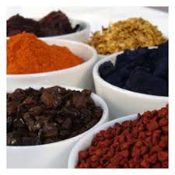

Some examples of clean trends are clean color and clean meals. The clean color trend focuses on replacing artificial colors with natural ones. The clean color trend in the U.S. roots from years of reports linking dyes to adverse behavior in children since 2008 in Europe. Clean meals is a trend to meet the demands of fast-paced society where consumers are looking to finish meals in a short time frame. This product is focused more on health-conscious consumers who are in search of alternatives for cup-ramen, also a quick but unhealthy meal. The clean meal products are a healthy substitute made of organic ingredients (Nielsen).

**Better Baking Trend** 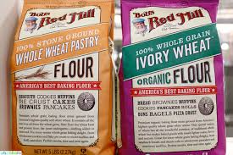

Another trend, the better baking trend offers organic ingredients for baking which captures the interests of mothers who love to bake for their children and also bakers who are looking for healthier ingredients in general (Nielsen). An example of organic baking ingredients is sold by Bob’s Red Mill which is resold in nearby grocery stores such as Safeway and Trader Joe’s.

**Animal Welfare Trend** 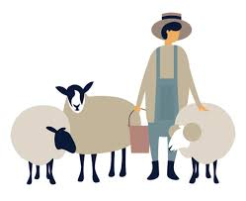

Organizations that care for animal welfare are also stepping up to contribute in the organic food industry. Grass-fed protein and dairy put emphasis on how the pastures are treated (given a free range to feed on natural foods, such as grass, instead of keeping them caged in a small space and only allowing them to feed on grains.) In September 2017, the national sales of organic meat increased as numbers of concerned consumers demanding for better welfare of animals and traceability increased. Also, according to the Nielsen Scantrack data, sales of organic meat, fish and poultry increased by nearly 14 percent at the end of September which reflects the community’s concern for animal welfare (The Herald Zimbabwe, 44). Here we can observe the impacts made by different segments of the population, in this case the animal welfare organizations, expressed in the organic food industry.

**Beverage Trend** 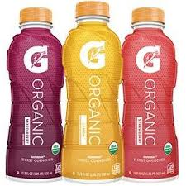

The beverage trend sells on the beverage’s benefit beyond quenching thirst such as, nutrition and fortification, natural energy boosts, etc. For example, a major sports drink company such as Gatorade started selling 100 percent USDA organic certified drinks with different flavors to appeal to athletes.

**Plant-Based Eats** 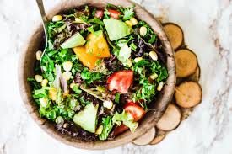

A popular trend in the organic industry is the plant-based eats which are choices made to minimize the usage of meats replacing them with vegetables, fruits, etc. The rising trend can be observed in companies such as Casco-based startup Freshiz, Yo’Novare of Portland and The Whole Almond and many others. Freshiez opened in April this year providing grocery stores with all-vegan and all-organic veggie crumbles and burgers. Sales quadrupled after just 6 months as requests from restaurants stacked up as well. Plant-based dairy is another sector under this trend where Yo’Novare produces yogurt made of cultured milk created from blend of chickpeas, lentils, almonds, cashews, pumpkin seeds and soybeans. The Whole Almond is another example of a company that started selling its organic almond and cashew milks in 2016. The rapid growth of this trend surfaced as the Netherlands based Innova Market Insights reports 63 percent rise of plant-based products on the market from 2011 to 2015 (Portland Press Herald, 53).

**Hospital Trend **

As consumers realize the potential health benefits of organic food, hospitals started to take action as well. By 2005, over two dozen hospitals added organic food services for their services, using organic foods to prepare meals for both staff and patients. Pacific Medical Center in San Francisco, CA and Dominican Hospital in Santa Cruz, CA are such examples of hospitals integrating the organic food services. Although the cost of organic food is high compared to conventional food, there are cases where hospital administrators report a profit from serving organic food options at their public cafeterias, indicating a number of ways approaches can be taken to negotiate high costs (Health Facilities Management, 51).

**Baby Food Trend** 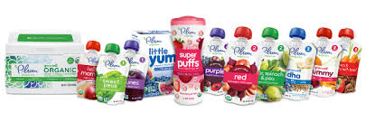

The Organic industry is also appearing in the baby food industry as parents are searching for safe and healthy ingredients to supply for their child’s needs. One such example of an organic baby food company is Plum Organics located in Emeryville, California. Plum Organics revolutionized the baby food category by using ingredients such as quinoa, kale and Greek yogurt and selling its products in innovative ways. Along with organic baby food, the company also sells organic snacks for toddler and kids and organic infant formulas (Contify Retail News, 43).

**Future Organic Trend**

The future of this industry is bright with numerous ways to approach and meet the consumer’s interests. Some of the rising trends that are forecasted are the rise of miso (a Japanese soybean paste product), baby foods using dry milk, and plant-based protein. The organic trend is growing on the global level as well, as the worldwide population starts to realize the importance of feeding our body with the natural goodness and the value it has to offer in the long run for health-related aspects. Therefore, there are numerous opportunities overseas as well as within the boundaries of the U.S. for the growth of the organic industry.

**Japan’s No. 1 Organic Miso maker** 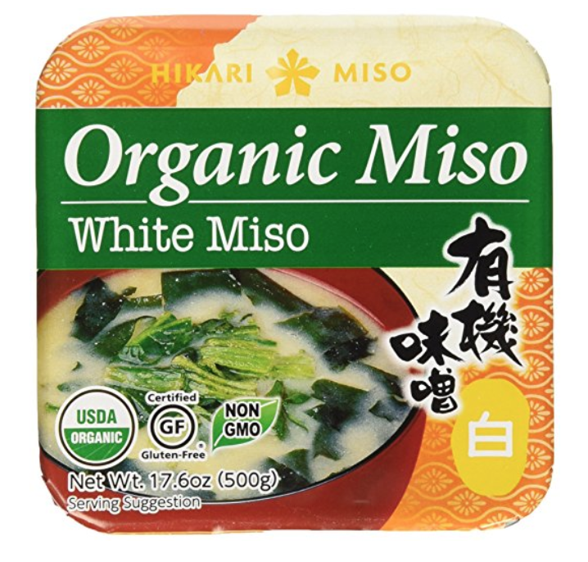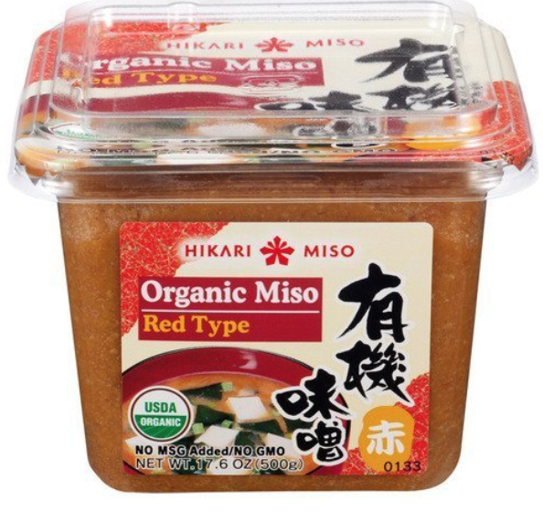

Founded in 1936, Hikari Miso is a family-owned miso manufacturer based in Nagano prefecture, Japan. The company’s recent launch of a website for English speakers across the globe opened new paths for consumers to reach out for their miso products, which are essentially made from fermented bean paste. Educated by the website of the health benefiting ingredients and recipes to refer to, consumers from over 30 countries are purchasing their products. Now, the company is celebrating double-digit growth in English-speaking countries and the integration of modern cooking styles with miso pastes might be leading to a new culinary innovation (PR Newswire, 52).

**Gene Alteration Trend** 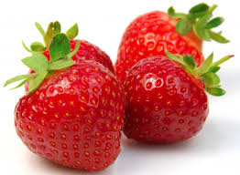

Amongst the trends for a variety of organic foods and beverages, there is also a positive outlook of scientific growth in the organic industry. At the University of New Hampshire (UNH) in the U.S., scientists worked to contribute to the organic agriculture by developing the first varieties of strawberries. The strawberries are certified as organic and are developed in a way that is environmentally friendly. This is a major contribution to the strawberry industry as well since it opens a new path for advancing genetic research within the scientific fields (The Herald Zimbabwe, 54).

**Organic Wine Trend** 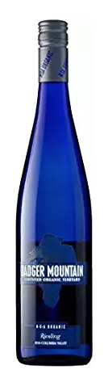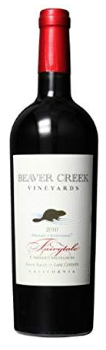 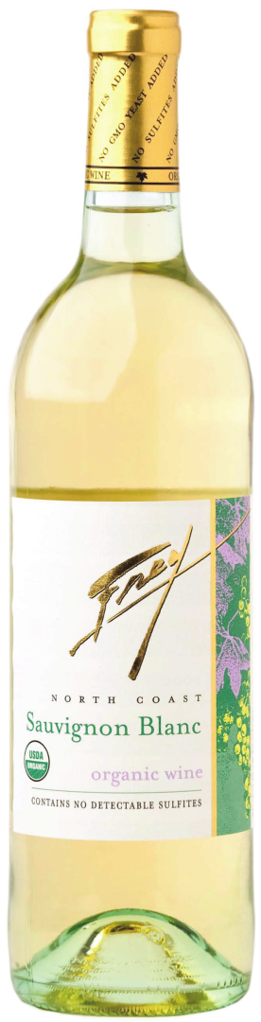 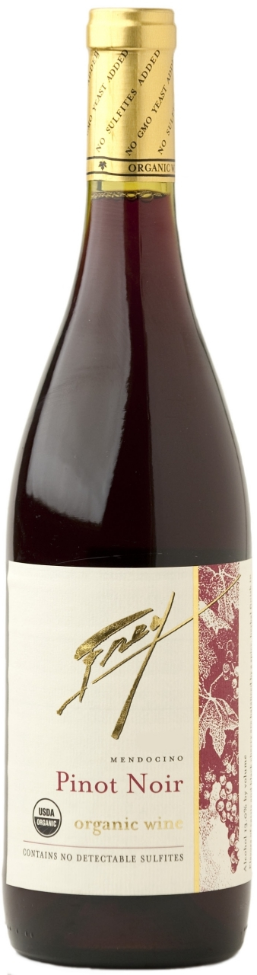

The organic wine trend is also on the rise as it is the prime candidate for the forecast of the $55 billion global beverage market by 2025. The number of organic vineyards tripled in the last decade, with the U.S. coming in fourth with 28,000 acres. Spanish winemakers are said to use over 38 grape varieties in production of wine and that also sheds light to the possible advances in the genetic science research as mentioned for the strawberries above. Some of the finest American wines represent the organic wine productions with the recent shift of the U.S. viticulture to the organic industry by wineries such as the Badger Mountain Riesling, Beaver Creek Cabernet Sauvignon, Frey Vineyards Pinot Noir, and Frey Vineyards Sauvignon Blanco. There are approximately 25 percent organic vineyards located in California and in 2017, the U.S. placed 4th in global organic sales for wine. The efforts made by wineries in areas such as Napa Valley, Willamette Valley, Columbia Valley, etc. are pulling the winemaking industry to be more sustainable and environmentally friendly by integrating advanced technologies (ACCESSWIRE, 46).

**Online Shopping Trends** 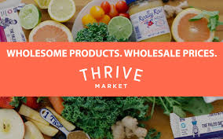

Amazon’s purchase of Whole Foods are creating new paths for smaller organic producers to engage in an alternative to expand their line of production. Whole Foods is an important company for start-ups since the company already gained trust and credibility from their long-time customers. Therefore, new businesses consider it a prime resource to initiate their trade on Whole Food’s shelves. Since Whole Food’s recent negotiation with Amazon’s delivery services, many organic companies are starting to gain hope of having the opportunity to supply more people within a larger coverage through Amazon’s delivery services, helping organic producers to spread their products around the nation (Layne, 45). Online organic shops such as the THRIVE Market is on the rise as well, shipping organic products readily and cheaper than the prices offered otherwise.

Keeping in mind that these are just a small sample of the trends that are observed in the organic food industry, there are further opportunities of manipulating consumer’s interest in this field.

**Resources**

Berry, Donna. "Natural & Organic." *Dairy Foods*, vol. 102, no. 1, Jan. 2001, p. 23. EBSCO*host*, search.ebscohost.com/login.aspx?direct=true&db=bth&AN=4070342&site=ehost-live.

Dimitri, Carolyn, and Catherine Greene. “Recent Growth Patterns in the U.S. Organic Foods Market.” *USDA*, USDA, Sept. 2002, www.ers.usda.gov/webdocs/publications/42455/12915_aib777_1_.pdf?v.

Dimitri, Carolyn, and Lydia Oberholtzer. “Marketing U.S. Organic Foods: Recent Trends From Farms to Consumers.” *USDA*, USDA, Sept. 2009, [www.ers.usda.gov/webdocs/publications/44430/11009_eib58_1_.pdf?v=41055](http://www.ers.usda.gov/webdocs/publications/44430/11009_eib58_1_.pdf?v=41055).

Gardyn, Rebecca. "The Big O." *American Demographics*, vol. 24, no. 9, Oct. 2002, p. 20. EBSCO*host*,

search.ebscohost.com/login.aspx?direct=true&db=bth&AN=7527131&site=ehost-live.

Greene, Catherine, et al. “Growing Organic Demand Provides High-Value Opportunities for Many Types of Producers.” *USDA ERS - Growing Organic Demand Provides High-Value Opportunities for Many Types of Producers*, USDA , 6 Feb. 2017, www.ers.usda.gov/amber-waves/2017/januaryfebruary/growing-organic-demand-provides-high-value-opportunities-for-many-types-of-producers/.

"Growing Number of Hospitals Add Organic Foods." *Health Facilities Management*, vol. 18, no. 8, Aug. 2005, p. 8. EBSCO*host*, search.ebscohost.com/login.aspx?direct=true&db=bth&AN=17955329&site=ehost-live.

“Japan's No. 1 Organic Miso Maker Launches New English Website.” PER Newswire, *Factiva*, 24 Oct. 2017, global.factiva.com/ha/default.aspx#./!?&_suid=150983360110308990308007792496.

Layne, Rachel. “Whole Foods Deal Excites Small Businesses.” USA Today, *Factiva*, 26 Oct. 2017, global.factiva.com/ha/default.aspx#./!?&_suid=150991987513003630559227186605.

“Maine Entrepreneurs Introduce New Wave of Plant-Based Eats.” Portland Press Herald, *Factiva*, 25 Oct. 2017, global.factiva.com/ha/default.aspx#./!?&_suid=1509837781652047276130522386595.

Nielsen, Kara. “Natural and Organic Food Trends Webinar.” MarketResearchDotCom, 2016, [www.youtube.com/watch?v=Ch77AKBYcw8&t=138s](http://www.youtube.com/watch?v=Ch77AKBYcw8&t=138s).

“Organic Meat Rise Driven by Animal Welfare.” *Factiva*, 25 Oct. 2017, global.factiva.com/ha/default.aspx#./!?&_suid=150992034670206874943369726869.

“Plum Organics Introduces a New Way to Spoon Feed Baby.” Contify Retail News, *Factiva*, 17 Oct. 2017, global.factiva.com/ha/default.aspx#./!?&_suid=150992072407306584683344001727.

“Scientists to Develop First Strawberry Varieties for U.S. Organic Production.” The Herald Zimbabwe, *Factiva*, 20 Oct. 2017, global.factiva.com/ha/default.aspx#./!?&_suid=1509837781652047276130522386595.

“Steven Zoernack - Shares a List of the Finest Organic Wines.” ACCESSWIRE, *Factiva*, 26 Oct. 2017, global.factiva.com/ha/default.aspx#./!?&_suid=150991839468100002641604192565872.